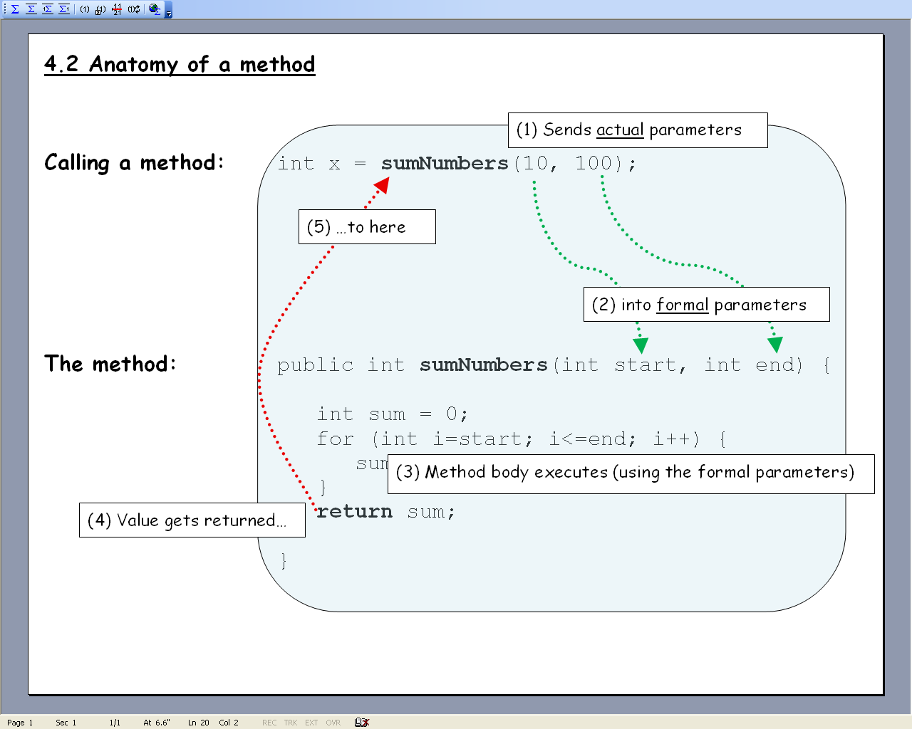
- Write a new project and class in eclipse with an main method. That is the entry point for Java programs.

- Add a method to the program called powersOfTwo that prints the first 10 powers of 2 (starting with 2). No parameters, no return value.

- Call powersOfTwo from inside the main method.

- Write a method called alarm that prints the string “Alarm!’ several times on separate lines. The method should accept an integer parameter that tells it how many times the string is to be printed. It shouldn’t return anything. Print an error message if the parameter is less than 1. One parameter, no return value.

- Call alarm from inside the main method. Send 8 as the actual parameter. Call alarm a second time and pass -5 for the actual parameter.

- Write a method called tenFactorial that calculates 10! (10 factorial, 10*9*8*…*1) and returns the answer as an integer. No parameters, has a return value.

- Call tenFactorial from inside the main method. Print the return value from inside the main method.

- Write a method called maxOfTwo that accepts two integer parameters and returns the larger of the two as an integer. Two parameters, has a return value.

- Call maxOfTwo three times from inside the main method:
  - The first time pass 10 and 21 for the parameters. Print the return value from inside the main method.
  - The second time pass 30 and 14. Print the return value from inside the main method.
  - The third time pass 23 and 23. Print the return value from inside the main method.

